Ideation Phase Empathize & Discover

Date | 15 Feb 2026
Team ID | LTVIP2026TMIDS85401
Project Name | Strategic Product Placement Analysis
Maximum Marks | 4 Marks

Empathy Map Canvas:
An empathy map is a simple, easy-to-digest visual that captures knowledge about a user’s behaviors and attitudes.
The primary user of the Strategic Product Placement Dashboard is a retail merchandiser, category manager, or marketing analyst who needs to monitor store-wide product performance, shelf-space efficiency, and sales fluctuations based on item location. The user often deals with massive rows of raw, unformatted point-of-sale (POS) and inventory data, lacking a centralized visual platform to analyze how product positioning impacts revenue or to clearly compare different store layouts and promotional periods.
Due to the absence of interactive and visual analytics, the user feels uncertain and overwhelmed while making shelf-allocation, cross-merchandising, and inventory decisions. They need a comprehensive, user-friendly Tableau dashboard with clear KPIs, sales trend analysis (such as conversion rates and seasonal spikes), and store-level or category filtering options. This will transform raw retail data into actionable insights for better operational and strategic decision-making regarding where products should be placed to maximize visibility and ROI.

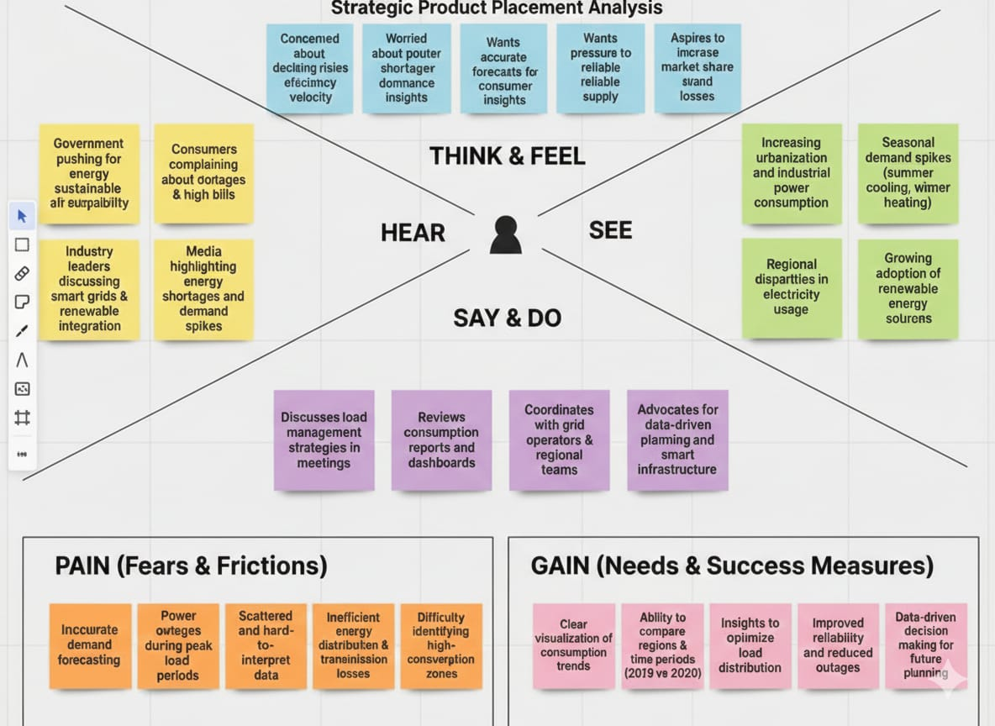
Data -driven decision making for future planning

